Pitching performance.

Next we have a summary table of pitching performance.
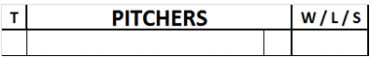
Next to the defense section there are spaces for each pitcher’s fielding performance. The defense section is only used if there is a Designated Hitter in the batting order.
The left-hand boxes of the pitchers’ table under the letter “T” are completed as follows:

- in the position column, put “R” or “L” to indicate whether the pitcher is right- or left-handed.
- write the name of the pitchers in full: surname in block capitals and then first name in small letters, in the order in which they pitched.
- next is the column for shirt numbers, the shirt numbers of the pitchers are noted.

The column W/L/S should indicate whether the pitcher is the winning or losing pitcher or gets a save.
Under the heading “PITCHERS” there are six lines, which are used for the starting pitcher and his substitutes.
At the end of the column the totals of each individual column are recorded, even in the event that a single pitcher was used.
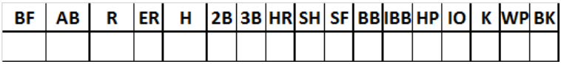
BF | Total number of Batters Faced.
AB | Number of batters officially At Bat against pitcher.
R | Number of Runs allowed.
ER | Number of Earned Runs allowed.
H | Number of Hits allowed. ATTENTION: This includes all safe hits, not just singles.
2B | Number of two-base hits / doubles allowed.
3B | Number of three-base hits / triples allowed.
HR | Number of Home Runs allowed.
SH | Number of Sacrifice Hits allowed.
SF | Number of Sacrifice Flies allowed.
BB | Total number of Bases on Balls allowed (including intentional).
IBB | Separate listing of any Intentional Bases on Balls allowed.
HP | Number of batters Hit by Pitched balls.
IO | Number of batters who reached first base through Interference or Obstruction.
K | Number of striKeouts.
WP | Number of Wild Pitches.
BK | Number of BalKs.

